INFORMATION TECHNOLOGY
QUESTION BANK
GRADE 10

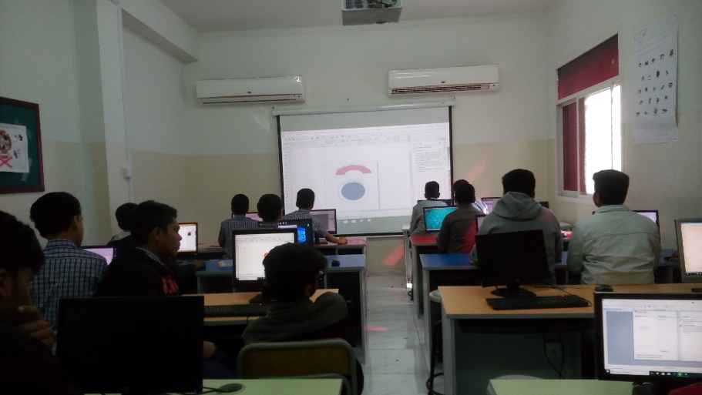

PREPARED BY
Ms.NIMMY & Ms.MALARVIZHI

